Nomination form for the
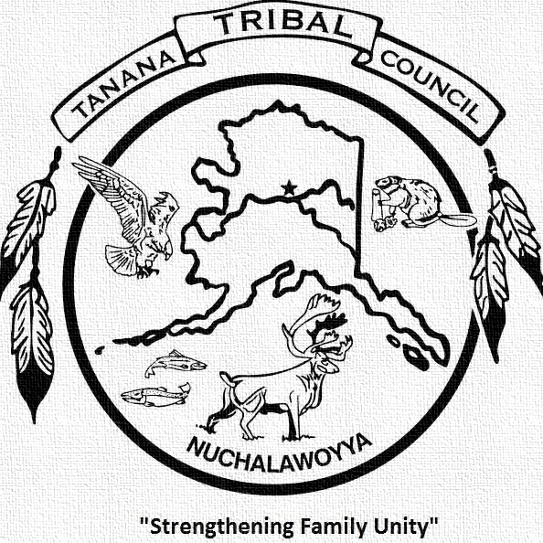
Patti L. Hyslop Sobriety Award
The Name of the Person who you are nominating to receive this award:

The Name of the Community/Village where this Person lives:

The Name of the Village, Tribe, or Person(s) submitting this nomination:

The Length of time that this Person has been free of Alcohol and Drugs:

Please write a statement about the person you have nominated; including community service, and how this person provides leadership in growth and healing, and examples of how this person is a role model in your community. Give the reasons why you believe this person should receive the Patti L. Hyslop Leadership in Sobriety Award

