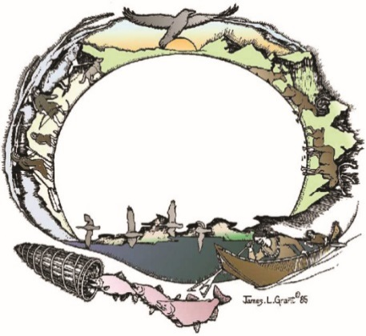

**Tanana Chiefs Conference**

**DISPLAY CASE ARTWORK REQUEST FOR PROPOSALS AND GUIDELINES**

Chief Andrew Isaac Health Center Expansion Project

1717B West Cowles Street, Fairbanks, Alaska

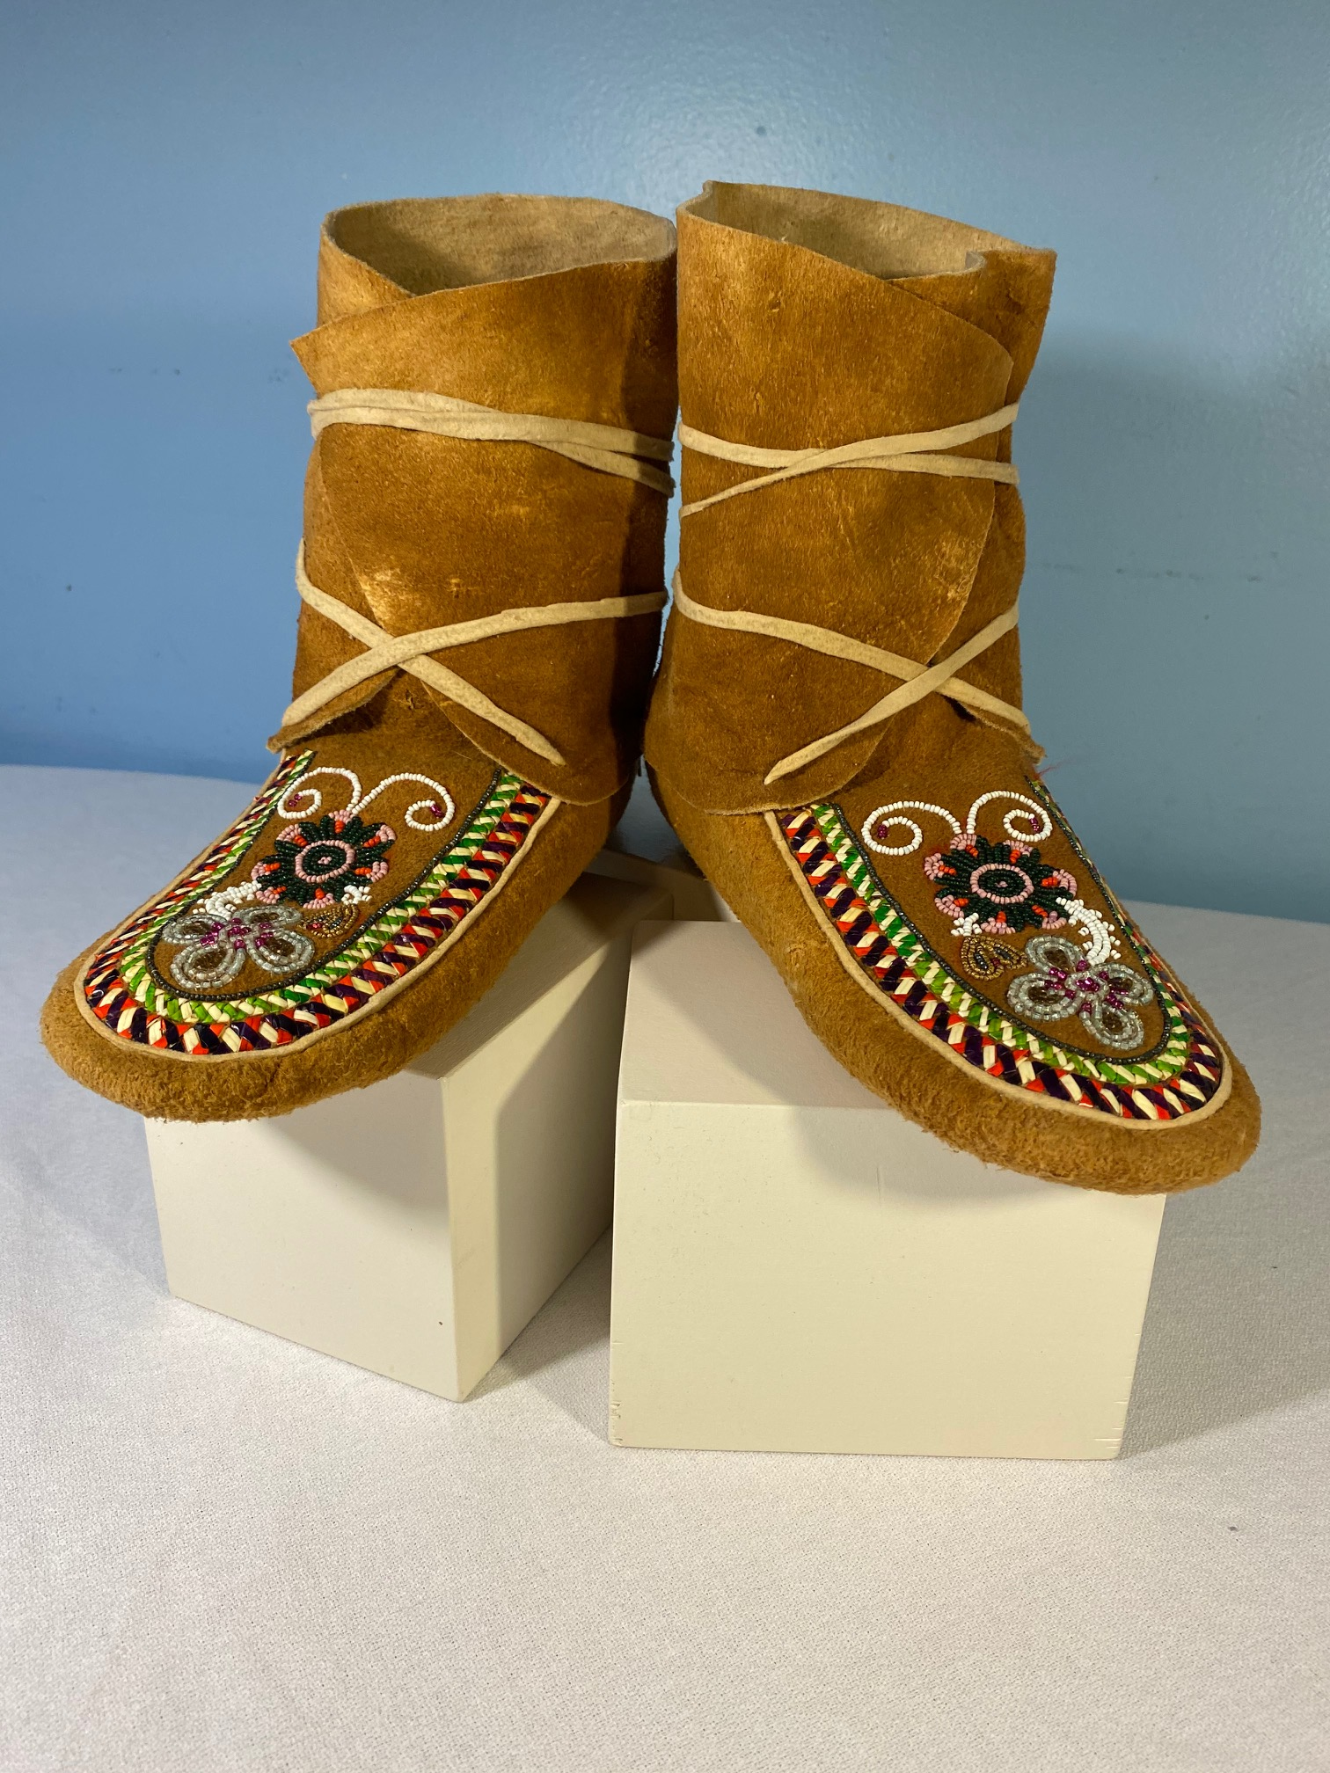

# GENERAL INFORMATION

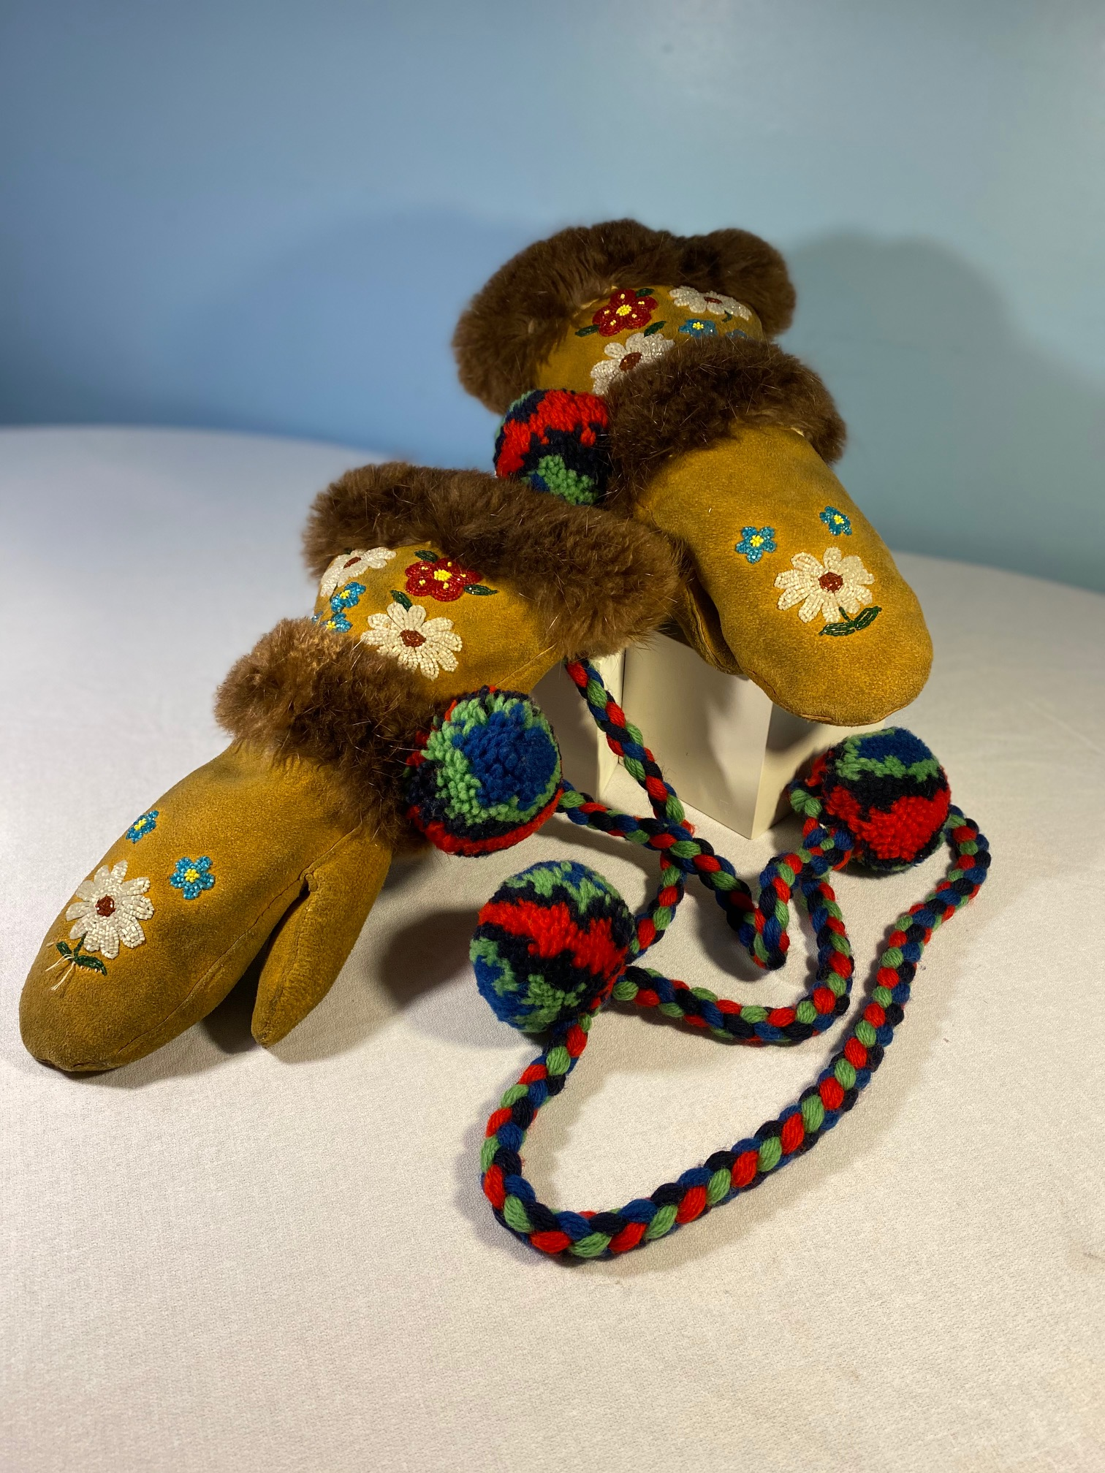Tanana Chiefs Conference (TCC) is soliciting display case artwork and collectibles for the new Chief Andrew Isaac Health Center Expansion Project located in Fairbanks, Alaska. TCC is interested in displaying Alaska Native Artwork items from the Interior Region of Alaska. Selection will be made based on artistic merit, qualifications, price, and best value. It is the policy of TCC to be an equal opportunity employer and to hire individuals, or contract with individuals or entities, solely on the basis of their qualifications and ability. This policy, however, is applied within the restrictions of Alaska Native and American Indian preference policies pursuant to Public Law 93-638, as amended. It is the policy of TCC to comply with section 7 of Public Law 93-638, as amended. TCC 10-203 Recruitment.

# SPECIFIC DISPLAY CASE ITEMS

TCC is specifically interested in proposals for the following items:

1. **Athabascan Regalia -** This traditional Athabascan regalia should include a fur parka, hat and mittens, pants, and boots that would be worn in the winter months. TCC is seeking regalia for both Male and Female.
2. **Dog Sled –** a small-scale replica of a traditional dog sled.
3. **Snowshoes –** full-size traditional snowshoes.
4. **Fish Wheel –** asmall-scale replica of a traditional fish wheel.
5. **Baby Carrier -** birch bark basket baby carrier.
6. 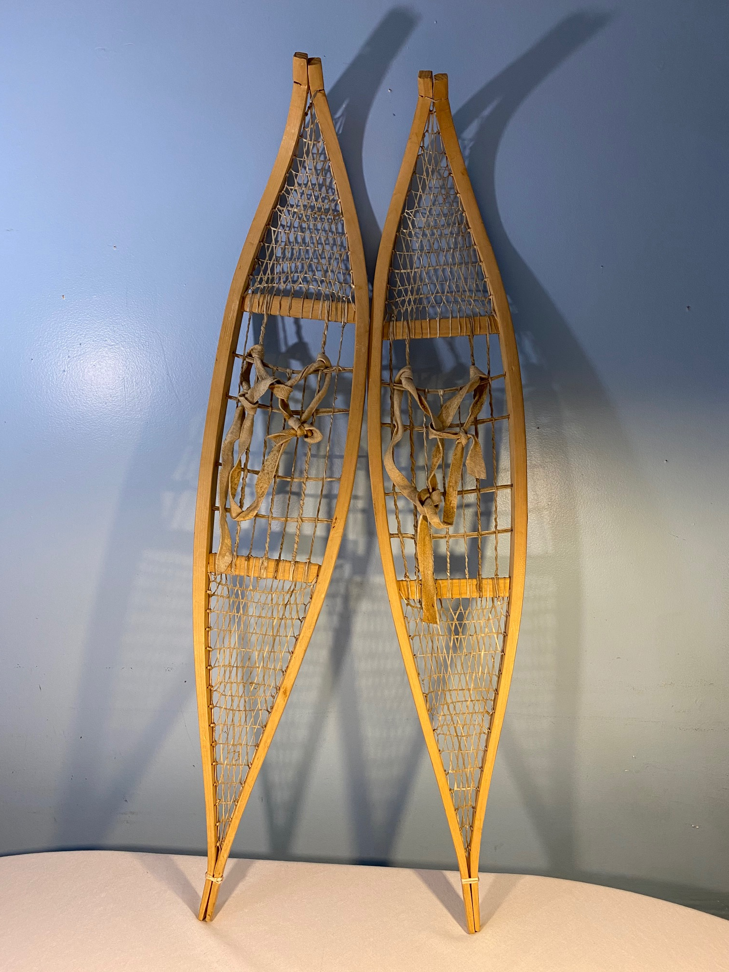**Traditional Basket Collection -** represents styles from various TCC regions. Larger flat baskets to be displayed on the wall (like wall art) or standup shelving.

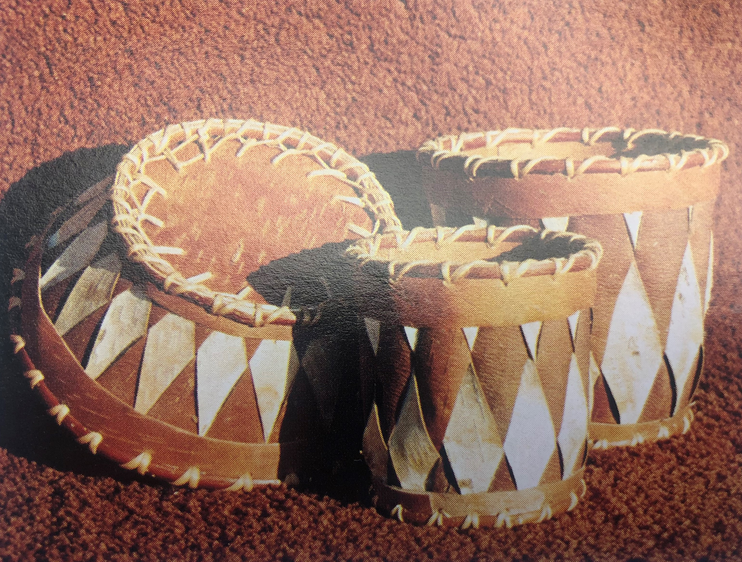

# Diagram, engineering drawing Description automatically generatedDISPLAY CASE DIMENSIONS

There are five different sizes of display cases located throughout the CAIHCX building. Proposed artwork items must fit within these display case dimensions.

|  |  |
| --- | --- |
| **Display Case Type** | **Dimensions (WxHxD)** |
| Type 1A | 30”x68”x6.5” |
| Type 1B | 59”x68”x6.5” |
| Type 1C | 91”x55”x6.5” |
| Type 2 | 88”x91”x14” |
| Type 3 | 75”x87”x 27" from base up to 38", then slopes inward to top (see photo) |

# ARTWORK ELIGIBILITY

1. Display case items submitted for consideration can be either original art, where the artist maintains ownership of the work OR it may be a part of the secondary market in which it was an original piece that was purchased and the current owner now wishes to have the art considered for sale or donation.
2. Display case items may be submitted from living and deceased artists and art collectors.
3. Artwork must be delivered to TCC in Fairbanks by July 8, 2022.

# PROPOSAL REQUIREMENTS AND FORMAT AND CONTENT

Artists or art collectors are invited to submit proposals for consideration by TCC Art Committee. Each art proposal must have:

1. A completed Artwork Proposal Form for each piece of art to be considered**.**
2. Artist biography statement.
3. Color-printed photographs or digital images of all sides of the artwork. For new artwork, provide a color sketch and photos of similar artwork created by the artist.
4. Purchase Price for the art (if the piece is for sale).
5. If the artwork is submitted as a donation, please indicate it on the Proposal Form.

# PROPOSAL DEADLINE AND SUBMISSION REQUIREMENTS

**Pre-Registration:** Interested artists must register with Terri Cadzow by sending their name, email, and phone number to artwork@tananachiefs.org or by calling 907-452-8251 Ext 3141.

**Proposal Deadline:** Art proposals must be received by TCC by **5:00 pm on Friday, March 21, 2022**. Proposals received after this deadline will not be considered.

Art Proposals may be submitted in person, by email, or by regular mail to:

Terri Cadzow

Tanana Chiefs Conference

Chief Peter John Tribal Building

122 1st Avenue

Fairbanks, AK 99701

RE: “CAIHCX Display Case Artwork Proposal”

# CONDITIONS OF PURCHASE

Once the artwork is recommended for approval by the TCC Art Committee, selected artists or the owner of the artwork will be notified. Any existing artwork must be ready for purchase at the time the proposal is submitted. If artwork is to be commissioned for this project, the artist must be willing to sign a contract to complete the proposed art piece at the time of proposal submission.

The artist or the owner of the art must make arrangements for the artwork to be delivered to TCC in Fairbanks by July 8, 2022.

Upon receipt of payment for the artwork, the artist or the owner acknowledges they are relinquishing all rights to the artwork and that the artwork or images of the artwork may be used in any printed or electronic media by TCC. Payment for the artwork will be issued once the artwork and all pertinent information are received. Artists may request early payment for materials; TCC will consider them on a case-by-case basis.

# RESITING/ROTATION/REMOVAL OF ART

After purchase, TCC reserves the right to relocate, rotate, remove or sell any of the art at any time.

1. OTHER

* All materials submitted in this proposal will become the property of TCC and will not be returned.
* TCC reserves the right to cancel this procurement effort and will not reimburse Proposers for any costs of preparation or submission of proposals.
* TCC may accept or reject any or all proposals without limitation, waive minor deviations from the RFP or specifications, and waive any informality in proposals received if TCC in its sole discretion determines that such acceptance, rejection, or waiver is in the best interest of TCC.
* Artists should not send in or ship any artwork to TCC until the purchase is negotiated/finalized and you have been notified by TCC.

# DISPLAY CASE ART PROPOSAL FORM

*If an artist is submitting multiple art pieces, please fill out a separate art proposal form for each piece.*

***Display Case Artwork Title:*** *________________________________________________*

***Artist****: ___________________________________________________________________*

***Owner****: ______________________________________* ***Phone****: _____________________*

***Email****: __________________________________________________________________*

***Art Dimensions (length x width x height):____________________________________***

***Photographs:*** Provide color photos or sketches of all sides of the art item – front, back and sides. Photos may be printed (8x10 size) and submitted with art proposal form or photos may be emailed to [artwork@tananachiefs.org](mailto:artwork@tananachiefs.org). If emailing photos, include Artist name and artwork title in the email subject line.

***Artwork Description***:_______________________________________________________ _____________________________________________________________________________________________________________________________________________________________________________________________________________________________________________________________________________________________________________________________________________________________________________

_________________________________________________________________________

**PRICE PROPOSAL** *(if Art is being donated to TCC, please put $0.00 for the Total Price)*

Artwork Purchase Price $________________________

Estimated Shipping Costs to Fairbanks $________________________

Estimated Insurance of Art Piece (During Shipping) $________________________

Other Anticipated Costs: $________________________

**TOTAL PRICE** $________________________

________________________________ __________________________

Artist or Owner Signature Date

Thank you for your interest in the TCC Art Program for the Chief Andrew Isaac Health Center Expansion.

If you have any questions, please call:

Terri Cadzow

Phone: 907-452-8251 Ext 3141

Email: artwork@tananachiefs.org

**Ana Baasee’**